Postal Life Insurance

Department of Post

Software Requirements Specification (SRS)/ Functional Requirements Specification (FRS)
Address Change & Name Change

INTERNAL APPROVAL FORM

Project Name: Address Change & Name Change
Version: 1.0
Submitted on:
 | Name | Date
Approved By:
Reviewed By:
Prepared By:

VERSION CONTROL LOG
Version | Date | Prepared By | Remarks
1

Table of Contents

1. Executive Summary 4
2. Project Scope 4
3. Business Requirements 4
4. Functional Requirements Specification 5
4.1 Online Name/Address Change Page 5
4.2 Non-Financial Service Request Indexing page 5
4.3 Name Change Page 6
4.4 Address Change Page 7
5. Attachments 9

1. Executive Summary
The purpose of this document is to define requirements for performing the Address Change and Name Change Transactions in Insurance Management System (IMS).

2. Project Scope
This scope will include the following modules:
- Address Change Process
- Name Change Process

3. Business Requirements

ID | Requirements
FS_ANC_001 | Policyholder should be able to request an address change online or at a post office.
FS_ANC_002 | System should validate the policy number and customer identity before allowing changes.
FS_ANC_003 | System should allow uploading of supporting documents (e.g., Aadhaar, Gazette Notification).
FS_ANC_004 | Address Change performed using Aadhar Authentication should get completed immediately without any interventions.
FS_ANC_005 | Admin users should be able to view pending requests and take action.
FS_ANC_006 | Address change should update communication address used for correspondence.
FS_ANC_007 | Policyholder should be able to request a name change with supporting documents.
FS_ANC_008 | Name Change performed using Aadhar Authentication should get completed immediately without any interventions.
FS_ANC_009 | Name change should reflect across all linked policies and documents.
FS_ANC_010 | Changes should be reflected in reports and dashboards.
FS_ANC_011 | All changes should be logged with timestamps and user IDs for audit trail.
FS_ANC_012 | System should generate acknowledgment receipt for customer.
FS_ANC_013 | System should send SMS/email notifications on status updates.

4. Functional Requirements Specification
Flow Diagram for Address Change and Name Change Process: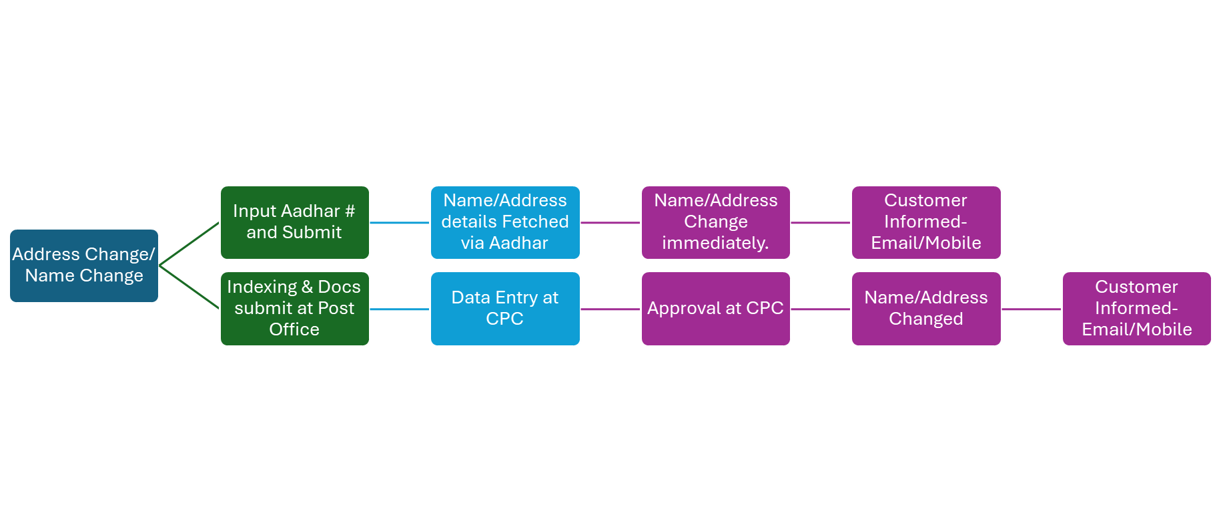

4.1 Online Name/Address Change Page
- To change the Name or Address online using Adhar based integration.
- Fields & Components:
  - Aadhar Number (Text field, mandatory)
  - Policy Number: Textbox: Mandatory
  - Change Type: Dropdown: Options are ‘Name Change’ and ‘Address Change’.
  - Submit (button)
- Business Rules:
  - Clicking on Submit button should fetch the Name or Address details as per option selected in ‘Change Type’ dropdown and should perform the Name or Address Change immediately.
  - Customer should immediately be informed via Email/SMS.
  - The Change should get reflected in Policies, Reports and at all other places in the system.
  - Audit Trail should be maintained for the Name Change and Address Change Transaction with User ID and Timestamp Details.

4.2 Non-Financial Service Request Indexing page
- Purpose: To create Non-Financial Service Request for Address Change and Name Change.
- Fields:
  - Request Type: Option should include service request type like Address Change, Name Change, etc.
  - Service Request Date: Calendar: Date on which service request is indexed.
  - Policy Number: Text
  - Office Code: Text: Facility ID of the office where request is getting indexed
  - Service Request Channel: Text: Channel for the service request like RICT, CP etc.
  - Username: Text: Emp ID of the user indexing the request
- Rules:
  - Request should get created and CPC User should be able to open the details.

4.3 Name Change Page
- Purpose: To perform the Name Change for the User.
- Field:
  - Request Type: Auto-Populated
  - Ticket No.: Auto-Populated
  - Salutation: Text: To Update the Salutation Details
  - First Name:
  - Middle Name:
  - Last Name:
  - List of Documents: Checkboxes: Checkboxes present should be ‘News Paper Notification’, ‘Name Change Application Form’ and ‘Gazette Notification’
  - Upload Documents: Button: Option should be present to upload the documents for the user.
  - Add Comments: Button: Option to Add comments in the request.
  - Request Missing Document Name: Dropdown: Options are ‘News Paper Notification’, ‘Name Change Application Form’ and ‘Gazette Notification’
  - Request Missing Document Date: Calendar
  - Request Missing Document Status: Dropdown
  - Request Missing Document Received Date: Calendar
  - Request Missing Document Delete: Icon: Option to delete the table row for Missing Document.
  - Request Missing Document Add: link: Option to Add the table row for Missing Document.
  - Submit: Button
- Rules:
  - Clicking on Submit button should update the Name details of the user.
  - If Request Missing Document is filled, the request should not be submitted and the notification should be sent to customer for submitting the missing documents.
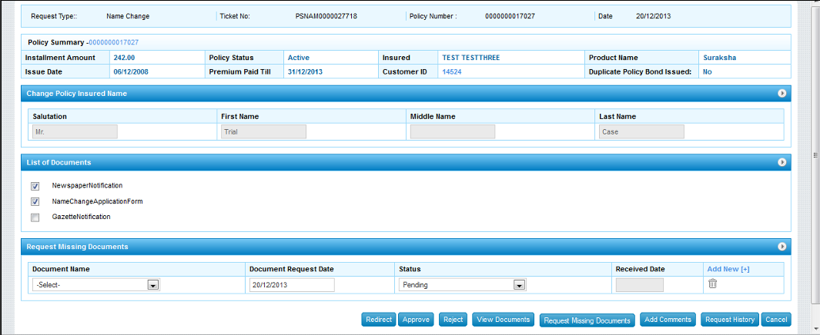

4.4 Address Change Page
- Purpose: To perform the Address Change for the User.
- Field:
  - Request Type: Auto-Populated
  - Ticket No.: Auto-Populated
  - Address Update For: Dropdown: Options should include Insured, Proposer, Assignee, Trustee
  - Address Type: Dropdown: options include official, communication, permanent.
  - Address Line1:
  - Address Line2:
  - Village: Text
  - Taluka: Text
  - City: Text
  - District: Text
  - State: Dropdown
  - Pincode: Text
  - Phone Type: Dropdown: options include official, communication, permanent.
  - Area Code: Text
  - Landline Number: Text
  - Mobile Number: Text
  - Aadhar Number: Text
  - PAN Number: Text
  - Passport Number: Text
  - Voter ID Number: Text
  - Date of Birth: Calendar
  - List of Documents: Checkboxes: Checkboxes present should be ‘Address Chang Application Form’, ‘Rental Agreement’ and ‘Address Proof’
  - Upload Documents: Button: Option should be present to upload the documents for the user.
  - Add Comments: Button: Option to Add comments in the request.
  - Request Missing Document Name: Dropdown: Options should be ‘Address Chang Application Form’, ‘Rental Agreement’ and ‘Address Proof’
  - Request Missing Document Date: Calendar
  - Request Missing Document Status: Dropdown
  - Request Missing Document Received Date: Calendar
  - Request Missing Document Delete: Icon: Option to delete the table row for Missing Document.
  - Request Missing Document Add: link: Option to Add the table row for Missing Document.
  - Submit: Button
- Rules:
  - Clicking on Submit button should update the Address details of the user.
  - If Request Missing Document is filled, the request should not be submitted and the notification should be sent to customer for submitting the missing documents.

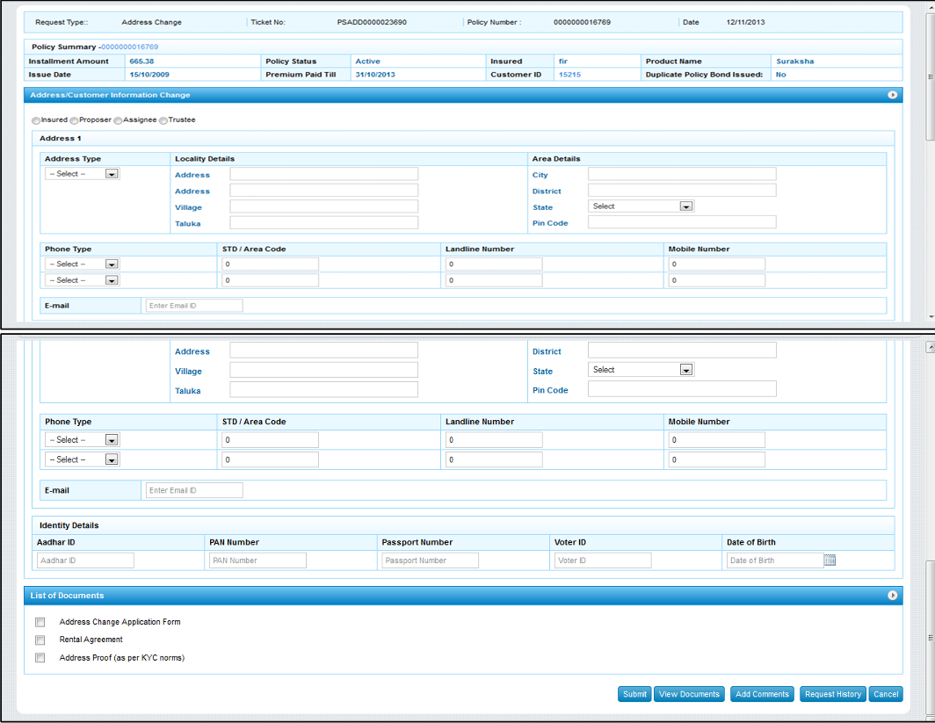

5. Attachments
The following documents can be referred:

